Summary of Hours

Due to this being a solo project, I worked offline or outside of a GitHub repository for the majority of the semester, only uploading my current state as items were due.

So the best proof I have is the below screenshot, highlighting my various iterations, all coming to a head at the end of march where I finally had to commit to one design in order to refine it enough for the expo.
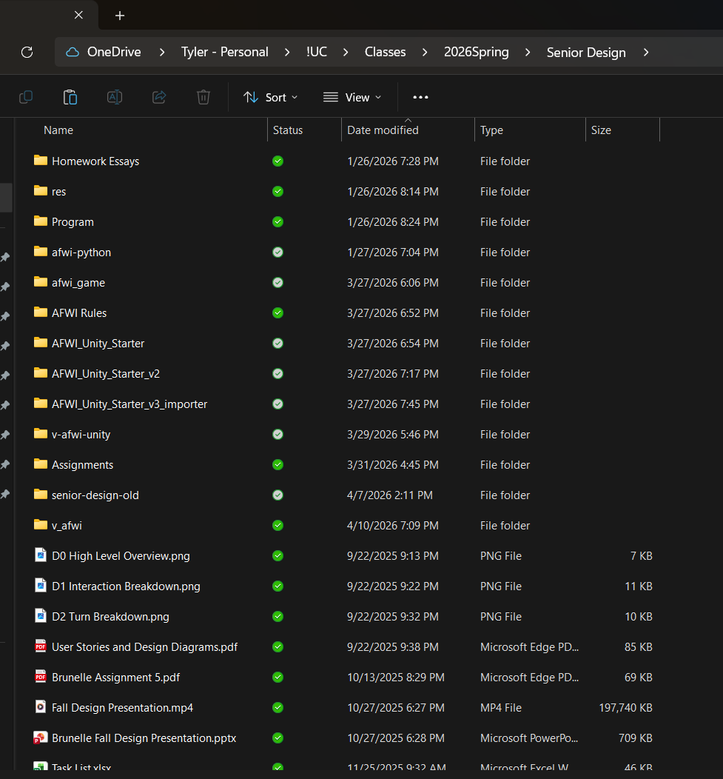
I tried a lot of different things throughout development, playing with different languages, packages, and even development software. This being my first time developing a game like this, I tried and failed in a lot of different ways. Fortunately I learn and was able to deliver a decent product.

